**DataSpark: Illuminating Insights for Global Electronics**

***(Dr.V.Kalpana, Assistant professor (c) TNJFU, Chennai)***

**Abstract**

In today's competitive electronics market, data-driven decision-making plays a crucial role in enhancing customer satisfaction, optimizing operational efficiency, and driving business growth. This study focuses on conducting a comprehensive Exploratory Data Analysis (EDA) for Global Electronics to uncover valuable insights from company data. By analysing customer behaviour, product performance, and operational processes, we aim to identify key trends, patterns, and areas for improvement. The findings from this analysis will provide actionable recommendations to streamline operations, enhance customer experiences, and support strategic decision-making, ultimately fostering long-term business success.

**1. Introduction**

In today’s highly competitive electronics market, data-driven decision-making is essential for enhancing customer satisfaction, improving operational efficiency, and driving business growth. Global Electronics, a leading player in the industry, generates vast amounts of data related to customer interactions, product performance, and operational processes. Effectively analyzing this data can unlock valuable insights that support strategic decision-making.

This study employs Exploratory Data Analysis (EDA) to uncover trends, patterns, and potential areas for improvement across key business functions. By analyzing customer behavior, sales performance, and operational efficiency, we aim to provide actionable recommendations that optimize product offerings, and enhance overall customer experience. The insights gained from this analysis will help Global Electronics make informed decisions, ultimately fostering long-term success and competitiveness in the market.

**2. Methodology**

This study follows a structured approach to data analysis, ensuring that the extracted insights are accurate, relevant, and actionable. The methodology consists of the following key steps:

**2. 1 Data Cleaning and Preparation**

To ensure data quality and consistency, the raw datasets undergo a thorough preprocessing phase:

* Identifying and handling missing values through imputation or removal based on the nature of the data.
* Converting data types where necessary, such as transforming date fields and standardizing numerical values.
* Merging relevant datasets, such as sales, product, and customer data, to create a comprehensive dataset for analysis.

**2.2 Data Loading into SQL Database**

* Creating appropriate relational tables in an SQL database to store the preprocessed data.
* Using **SQL INSERT** statements to populate the tables efficiently.
* Ensuring data integrity and indexing for optimized query performance.

**2.3 Data Visualization with Power BI**

* Establishing a connection between the SQL database and Power BI/Tableau.
* Importing data and creating interactive dashboards for exploratory and visual analysis.
* Designing visualizations such as bar charts, trend lines, heatmaps, and KPI indicators to highlight key business metrics.

**2.4 SQL Query Development**

* Formulating  **SQL queries** to extract critical insights from the dataset.
* Ensuring that these queries address key business questions, such as customer behavior trends, product performance, and sales analysis.
* Optimizing queries for efficiency and accuracy in data retrieval.

**3. Analysis**

This study involves a detailed exploratory analysis of Global Electronics’ data to uncover trends, patterns, and insights that drive business decisions. The analysis is structured into four key areas: **Customer Analysis, Sales Analysis, Product Analysis, and Store Analysis.**

**3.1 Customer Analysis**

**Gender Distribution:** Understanding the proportion of male, female, and other gender identities helps in tailoring marketing strategies and product recommendations based on customer preferences. A significant skew toward a particular gender may indicate opportunities for targeted campaigns.Calculate the proportion of male, female, and other gender identities.

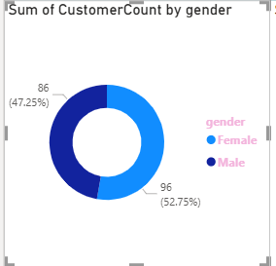

**Fig 3.1.1 pie chart to visualize the distribution**.

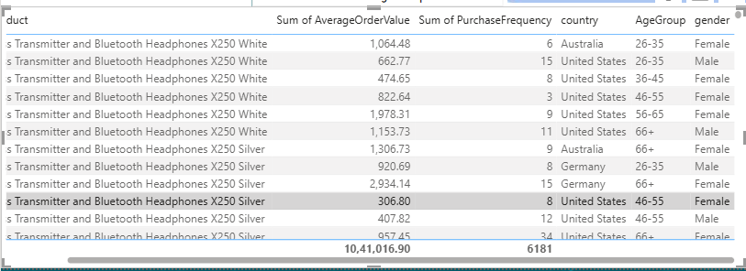

**Fig 3.1.2 Table to display the lists of products, country, age group, gender and frequency.**

**Age Distribution:** Analyzing the age distribution allows the identification of key customer segments. If the majority of customers belong to a specific age group, products and promotions can be optimized for that demographic. Additionally, recognizing underrepresented age groups can help in exploring new market opportunities.Compute age from the birthdate.

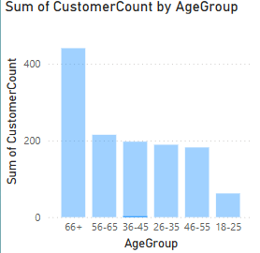

**Fig 3.1.3 Barchart to visualize the spread of ages.**

**Geographical Distribution:** Examining customer locations across cities, states, countries, and continents helps in assessing market reach and regional demand. High concentrations of customers in certain areas may indicate strong brand presence, while low customer density in specific regions may present expansion opportunities or highlight areas requiring improved marketing efforts. Analyze customer counts across cities, states, countries, and continent.

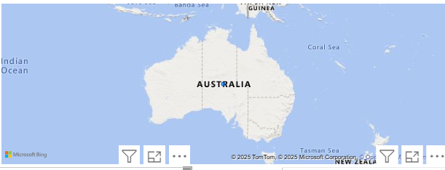

**Fig 3.1.4 maps to display the regional distribution of customers**

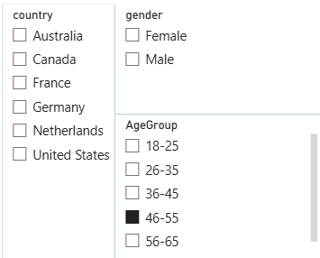

**Fig 3.1.5 Slicer to filtering country,Age and gender.**

**3.2 Sales Analysis**

The sales analysis provides valuable insights into revenue trends, product performance, and store contributions, helping Global Electronics optimize sales strategies and enhance profitability.

Overall Sales Performance:  
Analyzing total sales over time helps identify key trends, seasonal variations, and peak demand periods. Understanding these patterns allows the company to optimize inventory management, adjust marketing efforts, and forecast future sales accurately.

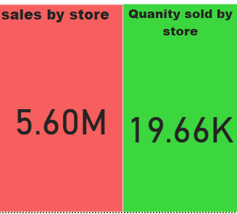  
**Fig 3.2.1 Total sales and total revenue**

* Sales by Product:  
  Ranking products based on quantity sold and revenue generated helps identify best-selling and underperforming items. High-performing products can be promoted further, while underperforming items may require pricing adjustments, marketing efforts, or product enhancements.

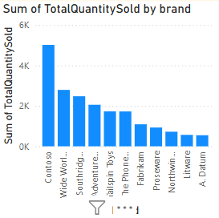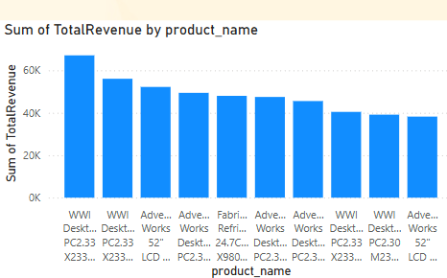

**Fig 3.2.2 Bar chart displays the Brand and quantity**

Sales by Currency:  
Assessing the impact of different currencies on sales helps in managing international transactions effectively. Exchange rate fluctuations can influence revenue figures, and understanding these impacts allows the company to refine pricing strategies and financial planning.

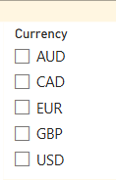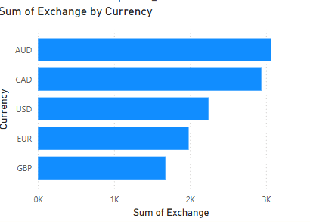

**Fig3.2.3 Slicer to filtering currency and year. Fig 3.2.4 Bar chart displays sum of exchange by currency**

**3.3 Product Analysis**

The product analysis provides critical insights into product demand, profitability, and category trends, helping Global Electronics optimize product offerings and pricing strategies. By analyzing sales data, the company can identify the most and least popular products. High-selling products indicate strong customer demand, suggesting opportunities for increased production or targeted marketing. Low-selling products may need pricing adjustments, bundling strategies, or discontinuation if demand remains weak. Calculating profit margins by comparing unit costs with selling prices helps determine which products generate the highest returns. Products with high profit margins can be prioritized in promotions, while low-margin products may require cost optimizations or price adjustments.

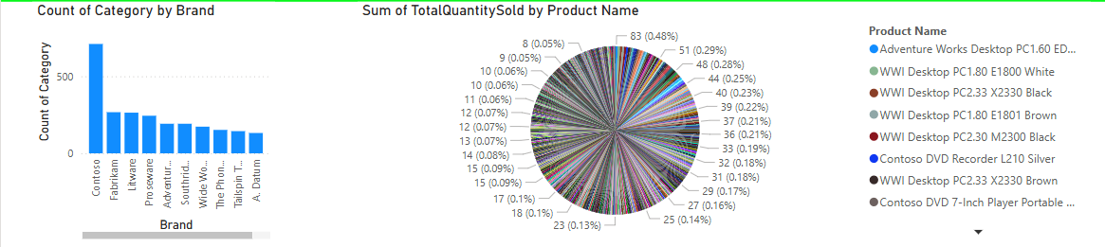

**Fig 3.3.1 Bar chart and pie chart displays the category of brand name and product name.**

Category Analysis:  
Examining sales performance across different product categories and subcategories helps understand customer preferences. This insight enables the company to focus on high-revenue categories, introduce new product lines, or refine inventory management to meet market demand effectively.

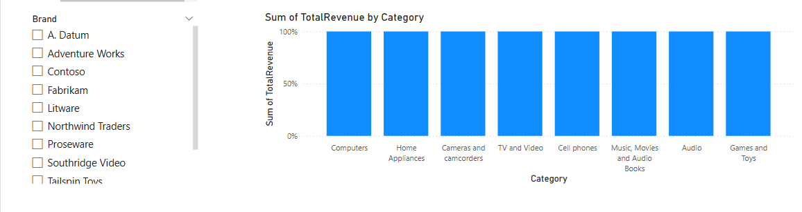

**Fig 3.3.2 Slicer to filtering brand Fig 3.3.3 Bar chart displays sum of total revenue by category**

**3.4 Store analysis**

Sales are analyzed by store location to identify high-performing regions and potential opportunities for expansion or improvement.

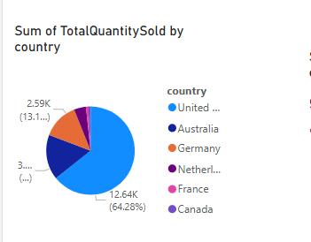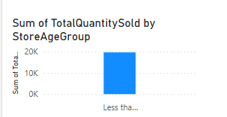

**Fig 3.4.1 Pie chart and bar chart displays Total quantity sold by country and age group**

**4.Conclusion**

Based on consumer data, male customers show a higher tendency to purchase electronic items compared to females. This trend may vary across product categories and demographics, requiring further analysis for targeted marketing strategies.